**Job Description**

**Prevention & activism Worker  
Recruitment pack**

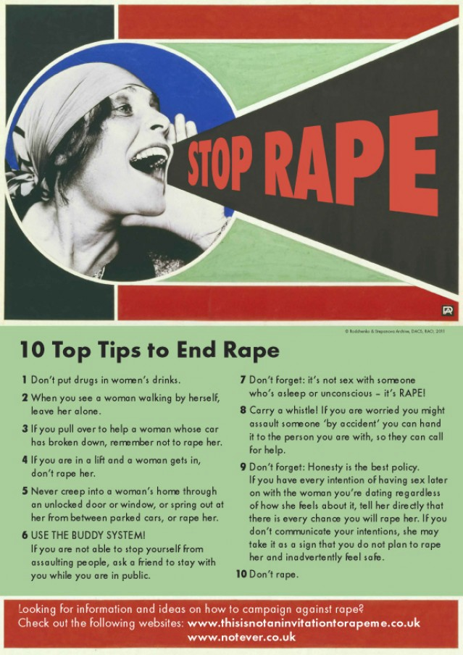



Dear Applicant,

Thank you for your interest in working with Shetland Rape Crisis. Please find enclosed the following documents:

* Information about Shetland Rape Crisis
* Advice on completing your application form
* Job Description and Person Specification
* Application form

**Please do not send a curriculum vitae (CV) as this will not be considered.**

Please note, all applications and relevant recruitment documents will be held confidentially and destroyed after 6 months, apart from documents relating to the successful applicant.

This post is: **25 hours per week (35 hour full-time week).**

Your completed application should be submitted via email by sending it to [contact@shetlandrapecrisis.scot](mailto:contact@shetlandrapecrisis.scot) **before midnight on Sunday 12th September.**

**Interviews will be carried at The Compass Centre on Wednesday 22nd September.**

**Please note only women need apply under Schedule 9, Part 1 of the Equality Act 2010**

We look forward to receiving your completed application form.

Yours sincerely,

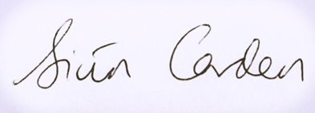

Siun Carden

Chair, Board of Trustees

# About our service

Shetland Rape Crisis has been supporting survivors of rape, sexual abuse and exploitation and raising awareness about the damaging effects of sexual violence in Shetland since 2016. We are a registered charity.

Shetland Rape Crisis has a small team of 7 part time staff members and a range of volunteers.

We provide a range of services to survivors of sexual violence, abuse and exploitation including:

**Emotional Support & Counselling Service**

We provide trauma-informed emotional and practical support and integrative counselling to survivors of sexual violence in Shetland. We currently have one Integrative Counsellor and two Support Workers.

**Advocacy & Support Service**

We are part of the National Advocacy Project for Scotland. Our dedicated Advocacy & Support Worker supports survivors who are thinking about or are engaging with the criminal justice system. This includes support in reporting to the police and court appearances. Other Support Workers in the service also provide advocacy support from time to time, with input from the specialist Advocacy Worker.

**Prevention & Activism**

We are funded for a specialist Sexual Violence Prevention & Activism Worker who works in all the secondary schools in Shetland delivering the Rape Crisis Scotland National Prevention Programme. This worker also facilitates BEE (Bold, Equal & Empowered) our young activists’ volunteer group.

**Training and Awareness-Raising**

We provide training on a range of topics including Zero Tolerance: healthy relationships for young people, No More! healthy relationships for learning disabled people, and specialist advice re: gender, GBV, and SV for other professionals. Additionally, we run community awareness raising events including a variety of events for the 16 Days of Action for Violence Against Women and International Women’s Day. All staff are expected to take part in this work.

# ADVICE ON COMPLETING YOUR APPLICATION FORM

As part of Shetland Rape Crisis commitment to equal opportunities, candidates for each post are treated equally. Application forms are the only basis on which the first selection is made to decide whom to call for interview. Therefore, only information, which appears on the form (and continuation pages), can be considered. It is **very** important that your completed form contains both the information we want about your skills and experience and the information you want to give us. These advice notes are intended to help you to complete your form effectively.

1. Read all the information provided especially the job description and person specification. These outline the duties you would be expected to carry out in this post and lists the skills, knowledge and abilities that the shortlisting/interview panel will be looking for.
2. Section 5 asks you to note down your general experience and is the most important part of your application. **This is your chance to explain why you are suitable for the job.** It is not enough to say you have the experience – you must demonstrate experience and skills with specific examples. Relevant experience may be from your current or previous jobs or from out with formal employment.
3. We have lots of information about our service on our website [www.shetlandrapecrisis.scot](http://www.shetlandrapecrisis.scot)
4. **Do not send your CV in addition to or in place of a completed application form as it will not be considered by the shortlisting panel.**
5. A Protection of Vulnerable Groups for Adults & Children is required as part of the job.
6. All applicants must complete all parts of the application form.
7. Application forms must arrive on time forms arriving late will not be considered.
8. References are normally taken up for the shortlisted applicants before interview. If you do not wish one or all references to be taken up at that point please indicate on the relevant page. It is our policy not to make a job offer without taking up references.

**Responsible to:** Shetland Rape Crisis Service Manager

**Salary:** £33,080 pro rata (25hr p/w), inc. Distant Islands Allowance

**Contracted to:** 30th September 2022

**Location:** Lerwick, Shetland.

**Holiday Entitlement:** 30 Days plus 12 Public Holidays (pro rata)

**Pension:** Employer contribution at 8% to pension fund.

|  |  |
| --- | --- |
| Job Title | Prevention & Activism Worker |

**Job Purpose**

Delivery of the National Sexual Violence Prevention Programme in Shetland

The post holder will continue to lead on the delivery of the Rape Crisis Scotland National Sexual Violence Prevention Programme in schools and youth groups in Shetland, using a shared resource pack and evaluation framework coordinated by RCS. Regular training opportunities and a practitioners’ forum are provided as part of the programme. More information and the report from an external evaluation can be found at <https://www.rapecrisisscotland.org.uk/prevention-work/>.

Delivery of Shetland Rape Crisis’ Activism Programme

The post holder will lead on local strategic approaches to sexual violence and gender-based violence in Shetland via the development, co-ordination, and facilitation of grassroots activism around these issues, giving our community a voice and empowering change. This includes volunteer coordination and facilitating BEE, Shetland Rape Crisis’ volunteer young activist group for young people aged 13-25, as well as taking a lead on campaigns and communications designed and fronted by SRC.

**Outcomes**

* Strategic approaches to sexual violence prevention in Shetland are more consistent and more effective.
* Strategic partnerships between SRC and local agencies are strengthened, promoting shared approaches to sexual violence and support for direct interventions.
* Young Shetlanders have increased knowledge and more positive attitudes towards sexual relationships, and less tolerance of violence.
* Young Shetlanders have a greater role in shaping interventions in relation to sexual relationships.
* Shetlanders interested in promoting or campaigning against gender-based violence and/or sexual violence are engaged, empowered and supported to have their voices and concerns heard.
* SRC is brought to the wider attention of the community to allow better service access and contribute to longer term cultural changes in attitude and behaviour around inequality, gender and sexual violence.

**Main Duties & Responsibilities**

**1. Delivery of prevention education**

The post holder will deliver educational programmes in schools and other community settings using the Rape Crisis Scotland sexual violence prevention pack.

The post holder will build on partnerships with schools and other education providers to plan education programmes and to support the development of policy and practice in relation to sexual violence, in accordance with existing priorities such as Curriculum for Excellence, Getting it Right for Every Child and child protection.

The post holder will deliver information sessions and training to school staff and parents/carers as required.

**2. Coordinating activism and campaigns**

The post holder will lead, develop, coordinate and facilitate BEE (Bold, Equal & Empowered), Shetland Rape Crisis’ young volunteer activists’ group (aged 13-25) to challenge sexual violence and gender-based violence within our community. You will be responsible for these young volunteers including all child protection responsibilities and risk assessment.

In line with Shetland Rape Crisis’ Communications Strategy and under supervision of the Service Manager and in conjunction with the Access & Prevention Worker, the post holder will take a lead on SRC’s social media presences and engagements with press and other key stakeholders to deliver our key messages.

The post holder will lead on and deliver campaigns, presentations and training at events to raise awareness of sexual violence and the impact on our community.

The post holder will develop materials and publicise the service, through visits, social media and written resources to enhance self-referrals and access to the service across voluntary and public sector agencies.

**3. Volunteer coordination**

The post holder will lead on volunteer coordination for the service, including all aspects of safeguarding, checks and appropriate maintaining of applications and details in accordance with GDPR, particularly for children and young people (aged 13-25).

**4. Strategic development**

The post holder will liaise with statutory and voluntary sector agencies (such as local education authority, youth and children’s services) and participate in multi-agency partnerships to develop strategic approaches to sexual violence prevention.

The post holder will liaise with Rape Crisis Scotland to increase connections and consistency between local and national approaches to prevention sexual violence.

The post holder will participate in practitioners’ forums with network of Rape Crisis prevention workers

The post holder will seek and develop opportunities for young people to be involved in shaping prevention and activism interventions.

**5. Support**

The post holder will respond sensitively to disclosures and facilitate young people’s access to support services as appropriate

The post holder will act on any child protection or wellbeing concerns identified according to the centre’s child protection policies and procedures. Where appropriate, they will participate in multi-agency initiatives to promote the young person’s safety and wellbeing.

**6. Monitoring and Evaluation**

The post holder will gather evaluation data from young people and link professionals using the materials in the Rape Crisis Scotland sexual violence prevention pack and pass this data to Rape Crisis Scotland and the Service Manager at SRC to inform revision of materials and funding reports.

The post holder will contribute to any agreed evaluation procedures including external evaluations and write regular reports on activities on activities and outcomes.

The post holder will lead on research into the prevalence of sexual violence against children and young people in Shetland and produce a report on the need for specialist intervention for under 13s who have been affected by sexual violence to be used in future service planning and funding applications.

**7. Equalities**

The post holder will promote and positively uphold SRC’s anti-discriminatory, non-violent and feminist values in all aspects of practice, in line with SRC’s vision and values.

**8. Accountability, supervision and professional development**

The post holder will attend regular support and supervision with the manager and external supervision.

The post holder will attend regular team meetings with the SRC staff.

The post holder will undertake training and development as required. This may include some off-island travel and overnight stays.

The post holder will act in accordance with SRC’s policies and procedures.

The post holder will undertake any duties consistent with the post as may be reasonably requested by the Service Manager.

**9. Team working and communication**

The post holder will work as a team with other centre employees.

The post holder will take part in awareness-raising activities or lead on awareness-raising projects as part of the wider organisational goals.

Work with other organisations on promoting survivor’s interests.

**10. General**

From time to time, you may be asked to undertake other tasks in line with SRC’s organisational goals.

**Person specification**

|  |  |  |  |  |
| --- | --- | --- | --- | --- |
| **CRITERIA** |  | **ESSENTIAL** |  | **DESIRABLE** |
| **Knowledge** | E1  E2  E3  E4 | Understanding of a feminist analysis of gender-based violence  Thorough knowledge of issues relating to sexual violence  Understanding of the impact of sexualisation of young people in the media and links with violence against women  Understanding of an intersectional approach | D1  D2 | Knowledge of approaches to sexual violence prevention  Knowledge of current legislation, policy and strategy relating to education and to the violence against women agenda |
| **Skills and Abilities** | E5  E6  E7  E8  E9 | Ability to engage with young people in a range of settings  Ability to communicate confidently and persuasively with a variety of groups, organisations and agencies.  Good communication skills both written and oral.  Ability to organize and prioritise workload, and capable of meeting tight deadlines.  Competence in use of IT, for example Word and Excel programmes, social media management, email and internet and delivery of Powerpoint presentation. | D3 | Ability to conduct research and write and produce reports. |
| **Experience** | E10  E11  E12  E13  E14 | Experience of delivering workshops/groupwork to young people  Experience of responding to disclosures  Experience of maintaining professional boundaries  Experience of child protection and vulnerable adult protection guidelines and legislation  Experience working effectively as part of a team | D4  D5  D6 | Experience of developing educational materials or groupwork programmes  Experience of working with people affected by gender-based violence  Experience of evaluating interventions aimed at young people |
| **Qualifications** | E15 | Qualification(s) in relevant area (e.g. in community education, social work, psychology, social sciences, gender studies, youth work or other related fields) or working towards this | D7  D8 | Degree in relevant area  Other qualifications in other relevant areas |
| **Other** | E16  E17  E18 | Ability to drive and access to a car for travelling to schools  Able to work flexibly and to undertake some evening and weekend work  Commitment to anti-discriminatory practice |  |  |

**Application to Shetland Rape Crisis**

**for the post of**

**Prevention & Activism Worker**

**To be returned to:** contact@shetlandrapecrisis.scot

|  |  |
| --- | --- |
| **Section 1: Personal details** | |
| Surname: | First name: |
| Address: | Tel (home): |
| Tel (mobile): |
| Tel (work):  May we contact you at work? |
| Postcode: | Email address: |

|  |  |  |  |  |  |  |  |  |  |  |  |
| --- | --- | --- | --- | --- | --- | --- | --- | --- | --- | --- | --- |
| **Section 2: Qualifications and training**  **(only enter those qualifications and/or training necessary or relevant to the job)** | | | | | | | | | | | |
| Qualification and/or training | | | | Subject | | | | | | Date | |
|  | | | |  | | | | | |  | |
|  | | | |  | | | | | |  | |
|  | | | |  | | | | | |  | |
|  | | | |  | | | | | |  | |
|  | | | |  | | | | | |  | |
|  | | | |  | | | | | |  | |
|  | | | |  | | | | | |  | |
|  | | | |  | | | | | |  | |
|  | | | |  | | | | | |  | |
|  | | | |  | | | | | |  | |
|  | | | |  | | | | | |  | |
|  | | | |  | | | | | |  | |
|  | | | |  | | | | | |  | |
|  | | | |  | | | | | |  | |
|  | | | |  | | | | | |  | |
|  | | | |  | | | | | |  | |
|  | | | |  | | | | | |  | |
|  | | | |  | | | | | |  | |
|  | | | |  | | | | | |  | |
|  | | | |  | | | | | |  | |
|  | | | |  | | | | | |  | |
|  | | | |  | | | | | |  | |
|  | | | |  | | | | | |  | |
|  | | | |  | | | | | |  | |
|  | | | |  | | | | | |  | |
|  | | | |  | | | | | |  | |
|  | | | |  | | | | | |  | |
|  | | | |  | | | | | |  | |
| **Section 3: Present employer** | | | | | | | | | | | |
| Name & address of employer: | | | | | | Date commenced employment: | | | | | |
| Job title: | | | | | | Notice required: | | Current salary: | | | |
| Brief description of your main duties and responsibilities, with an emphasis, where possible, on those areas most relevant to the job applied for: | | | | | | | | | | | |
| **Section 4: Previous employment (list in order, with most recent employer first)** | | | | | | | | | | | |
| Please list **all** your previous employment, detailing any gaps between employments with reasons (continue on a separate sheet if necessary). | | | | | | | | | | | |
| Dates | | Name and address of employer | | | | Job title and nature of work | | | Reason for leaving | | |
| From  DD/MM/YY | To  DD/MM/YY |
|  |  |  | | | |  | | |  | | |
|  |  |  | | | |  | | |  | | |
|  |  |  | | | |  | | |  | | |
|  |  |  | | | |  | | |  | | |
|  |  |  | | | |  | | |  | | |
|  |  |  | | | |  | | |  | | |
|  |  |  | | | |  | | |  | | |
|  |  |  | | | |  | | |  | | |
|  |  |  | | | |  | | |  | | |
|  |  |  | | | |  | | |  | | |
|  |  |  | | | |  | | |  | | |
| **Section 5: Relevant skills, experience and abilities**  **With reference to the job description and person specification, please outline how your work experience (including unpaid work) training, skills and abilities would enable you to carry out the duties of this post. Please include any information which you feel is relevant, paying specific attention to the Essential and Desirable points in the person specification as shortlisting will be based on your answering each point. Shortlisting will be based on the information given in this application so please be explicit and give examples from your own practice where helpful.** | | | | | | | | | | |  |
|  | | | | | | | | | | |  |
| **Section 6: References** | | | | | | | | | | |  |
| Shetland Rape Crisis requires a minimum of 2 employment references to cover a three-year period – if necessary, please provide further referees covering the last 3 years. | | | | | | | | | | |  |
| **Reference 1: Current / most recent employer** | | | | | | | | | | |  |
| Name: | | | Position: | | | | Tel no: | | | |  |
| Company name: | | | | | Email:  Address: | | | | | |  |
| May we, with discretion, contact your employer to discuss this reference: | | | | |  |
| **Reference 2: Previous employer / supervisor** | | | | | | | | | | |  |
| Name: | | | Position: | | | | Tel no: | | | |  |
| Company name: | | | | | Email:  Address: | | | | | |  |
| May we, with discretion, contact your previous employer to discuss this reference: | | | | |  |
| **Reference 3: Previous employer / supervisor** | | | | | | | | | | |  |
| Name: | | | Position: | | | | Tel no: | | | |  |
| Company name: | | | | | Email:  Address: | | | | | |  |
| May we, with discretion, contact your previous employer to discuss this reference: | | | | |  |

|  |
| --- |
| **Section 7: Declaration** |
| I certify that all the information contained in this form and any attachments is true and correct to the best of my knowledge. Offers of employment will be subject to satisfactory references, a PVG check and compliance with UK working restrictions. I realise that false information or omissions may lead to dismissal without notice.  Signature:  Date: |